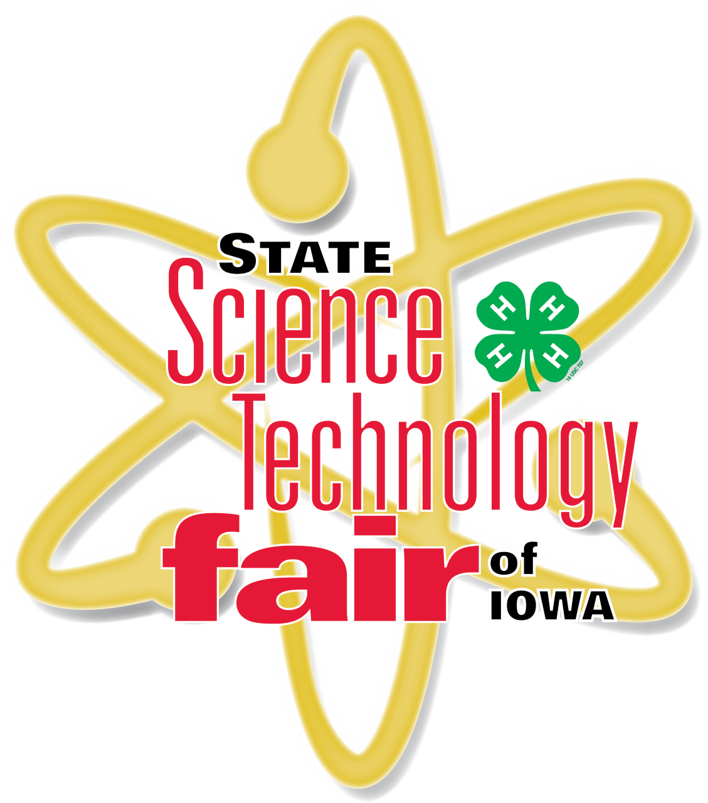
2022 State Science and Technology Fair of Iowa
Hilton Coliseum, Iowa State University, Ames, Iowa

SENIOR HIGH EVENT
Day 1
Thursday, March 24, 2022

7:00 – 8:30 am Exhibitor Registration & Project Set-Up Registration Desk, Outer Concourse
(Enter Through South Doors)

7:00 – 8:30 am Project Reviews Floor of Hilton
SRC Violation Clearance SRC Booth, Inner Concourse South
Display and Safety (DSC) Reviews/Clearance DSC Booth, Floor of Hilton

8:30 – 9:00 am Welcome Ceremony & Orientation Stage, Floor Level

8:30 – 9:00 am Project Viewing (Judges ONLY) Floor of Hilton
Floor MUST be clear of ALL Exhibitors!

9:00 – 12:00 pm Interview & Special Award Judging Floor of Hilton

9:00 – 12:00 pm Iowa FFA Agriscience Fair Judging (7th, 8th & HS) Floor of Hilton

9:00 – 9:45 am Hall of Fame Reception Pete Taylor Media Room
9:45 - 10:30 am Teacher Workshop Pete Taylor Media Room

12:00 – 1:15 pm Lunch program Included for all participants Hilton

1:30 pm Interview Judging Resumes – Finals Floor of Hilton

3:45 pm Interview Judging Concluded
Please wait to be dismissed before leaving projects.

1:00 – 3:30 pm Senior High Exhibits Public Viewing Floor of Hilton

4:00 pm Science Demonstrations presented by SCUM Stage, Floor Level

5:00 – 7:00 pm GRAND SENIOR HIGH AWARD CEREMONY Stage, Floor Level

There will be an ISEF qualifier registration and procedural meetings on Friday, March 25, 2022 @ 9:00 am in the Pete Taylor Media Room

2022 State Science and Technology Fair of Iowa
Hilton Coliseum, Iowa State University, Ames, Iowa

SENIOR HIGH EVENT
Day 2
Friday, March 25, 2022

7:00 – 9:00 am Volunteer Opportunity Registration Desk, Outer Concourse
*Help Behind the Scenes with Junior High Registration and Display and Safety Checks

8:00 am Grand Award Winners Registration Desk, Outer Concourse
& ISEF Qualifiers Projects Set-Up

9:00 am ISEF Qualifier Meeting Pete Taylor Media Room

10:30 am Grand Award Winners TBD & ISEF Qualifier Media Interviews

4:00 pm Seating for Junior High Grand Award Ceremony Stage, Floor Level

5:00 – 7:00 pm GRAND JUNIOR HIGH AWARD CEREMONY Stage, Floor Level

