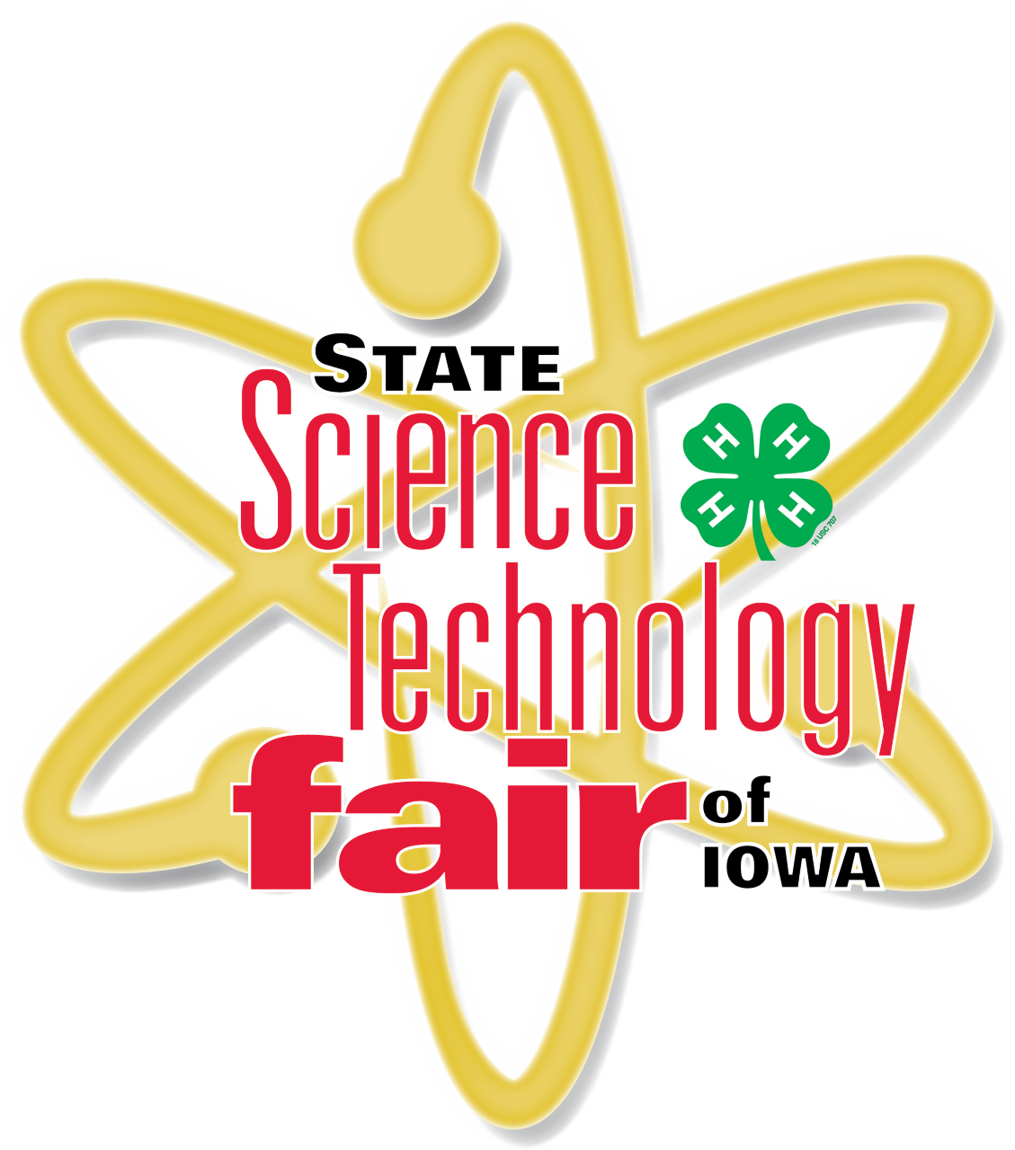
2022 State Science and Technology Fair of Iowa
Hilton Coliseum, Iowa State University, Ames, Iowa

JUNIOR HIGH EVENT
Day 1
Thursday, March 24, 2022

7:00 am Iowa FFA Agriscience Fair Registration & Set-up
*Please see Senior High event schedule if you are a 7th or 8th Grade FFA Agriscience Fair participant. You are required to attend Thursday as a judging day and attend the Senior High Award Ceremony if participating in the Iowa FFA Agriscience Fair Event.

9:00 – 12:00 pm Agriscience Judging

12:00 -1:00 pm Lunch

1:30 – 3:45 pm Judging Resumes

4:00 pm Projects Released

4:00 pm Science Demonstrations presented by SCUM

5:00 – 7:00 pm GRAND SENIOR HIGH AWARD CEREMONY

2022 State Science and Technology Fair of Iowa
Hilton Coliseum, Iowa State University, Ames, Iowa

JUNIOR HIGH EVENT
Day 2
Friday, March 25, 2022

7:00 – 8:30 am Exhibitor Registration & Project Set-Up Registration Desk, Outer Concourse
(South Side, Enter Through South doors)

7:30 – 8:30 am Project Reviews Floor of Hilton
SRC Violation Clearance SRC Booth, Floor of Hilton
Display and Safety (DSC) Reviews/Clearance DSC Booth, Floor of Hilton

8:30 – 9:00 am Welcome Ceremony & Orientation Stage, Floor Level

8:30 – 9:00 am Project Viewing (Judges ONLY) Floor of Hilton
Floor MUST be clear of ALL Exhibitors!

9:00 – 12:00 pm Interview & Special Award Judging Floor of Hilton

9:00 – 4:00 pm Jr High Public Viewing Floor of Hilton

10:00 – 11:00 am Teacher Workshop Pete Taylor Media Room

12:00 – 12:45 pm LUNCH On your own
(Concessions Available South Side Inner Concourse of Hilton)

1:00 pm Interview Judging Resumes Floor of Hilton

1:30 – 3:30 pm Alternate Judging (Division by Categories)

4:00 pm Interview Judging Concluded
Please wait to be dismissed before leaving projects.

4:00 pm Projects Released Floor of Hilton

4:00 pm Science Demonstrations presented by SCUM Stage, Floor Level

5:00 – 7:00 pm GRAND JUNIOR HIGH AWARD CEREMONY Stage, Floor Level

